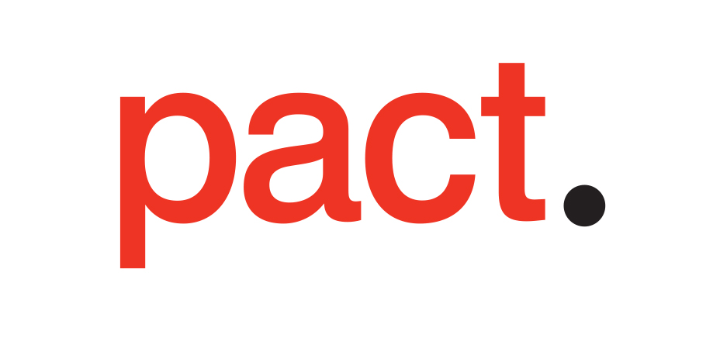

Environmental Policy Template

[Company Name] is committed to helping deliver an environmentally sustainable media production industry. We seek to better understand and manage our impact, implementing initiatives to act on our opportunity to make a meaningful difference.

Our impacts are:

- use data to support these statements, for example by using albert to identify what your most significant impacts are.

Our potential to make a difference:

- List all stakeholders such as office staff, crew, cast, suppliers, sub-contractors, studios, audiences, etc., articulating how you plan to use your influence to further environmental sustainability in the industry.*

Our actions:

Based on the impacts and influence you have identified above, this is where you should list measures put in place to deliver on your environmental ambitions. They should be specific, measurable, achievable, relevant and time-limited. Where appropriate, make it clear who is responsible for achieving each one. They may include;

- Procuring green energy from companies exclusively selling 100% renewable power.
- Putting sustainability questions in to all our supplier contracts.
- Offering sustainability training to all our stakeholders through BAFTA albert’s free Carbon Literacy industry training scheme.
- Offsetting the unavoidable elements of our carbon footprint (i.e travel)
- Operating a zero-to-landfill policy across all our operations (offices and productions).
- Ensure that all of our productions comply with relevant environmental legislation, regulations and codes of practice.
- Follow best practise for sustainable production by procuring sustainable goods and services.

[Insert name(s) of staff member(s)] will be responsible for monitoring our progress and reviewing these aims. The next review date will be [Enter date here].

Signed by
[Insert signature, name and role of relevant senior manager]

